ROLLS RUBBER COVERING ORDER

QUOTATION ORDER

  Industrijska 3. 21000 Novi Sad,  Tel./Fax: 21/4892-800, 21/4892-805  beta-roll@beta-roll.rs  www.beta-roll.rs | Buyer:
 | Address:
 | Phone: | Fax:
 | Administrator: E-mail:
To avoide mistakes
please provide most correct answers.
Machine type: | Drawing number: | Order number:
Roll function: |  | Requested delivery term:

Piece: | Metal diameter:  (mm) | Finished diameter:  (mm) |  |  | Sup. fic lenght: | Full lenght: | Hardness: |  | Producers field!
 |  |  |  |  |  |  |  | ShA | Producers field!
Piece: | Metal diameter:  (mm) |  | ± |  | Sup. fic lenght: | Full lenght: |  | P&J | Producers field!
Bearing force of roll:

Roll ends forming:
R=
Mechanical: | Chemical:
- rotation 1/min.: | - acid:
- pressure: | - alkali:
- axis load: | - paint:
- roll-mass: | - lacquer:
- other: | - oil:
 | - detergent:
Industrial temperature: | - other:
Type of material between two rolls and hardness: | The opposite roll’s cover type and its hardness:
Request for renewing roll body? Yes  (worn bearing surfaces, basic surfaces) No | Do you want new roll body? Yes  No
Other data, notice: | Shaft and face-wall covering: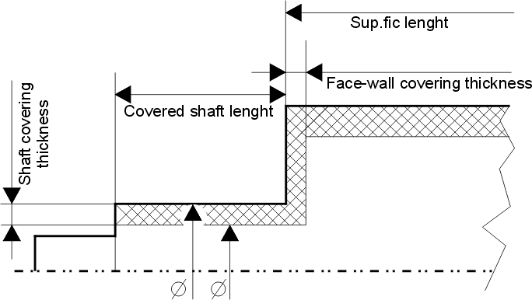

X °

X °

If the data above are insufficient to renew rolls’ rubber covering
and to make the eventual grooves we request the roll sketch.

Date:
Buyer

Producers field!
BRS-0001-01-01

